Use Case Realisation Report (Analysis) - Propose Project
FOR
Volunteer Management System
(VMS)

CLIENT
PROJECT | Volunteer Management System (VMS)Volunteer Management System
TITLE | Use Case Realisation Report (Analysis) - Propose Project
VERSION | 0.3a0.2a
DATE | 13-Aug-2011
 | ORIGINATOR
 | Name / Signature | Team 8S
 | APPROVAL
 | Name / Signature | Phung Kim Cuong, Dio
Institute of Systems Science |  | Document Reference
25 Heng Mui Keng Terrence  Singapore 119615 |  | VMS/T-1.4.1/1

 | Acceptance
 | Customer Signature |  | Customer Signature
 | Name & Designation |  | Name & Designation
 | Date & Company Stamp |  | Date & Company Stamp

Revision History

Date | Version | Description | Author
12-Jun-2011 | 0.1a | Creation | Team 8S
12-Aug-2011 | 0.2a | Updates | Team 8S
12-Aug-2011 | 0.3a | Updates | Team 8S

Table of Contents

1. Brief Description 3
2. Flow of Events 3
Standard Flow 3
2.1 3
2.2 Exceptions 4
3. Interaction Diagrams 5
3.1 Collaboration Diagram for Propose Project 5
4. Participating Objects 5
4.1 Volunteer 5
4.2 ProjectProposal 5
4.3 Document 5
4.4 ProjectListingScreen 5
4.5 ProjectProposalScreen 5
4.6 ProjectController 6
5. Class Diagram 6
6. Derived Requirements 6
ANNEX D Amendment History 7

Use Case Realisation Report (Analysis) - Propose Project

Brief Description
The use case enables registered user to propose new project.

Flow of Events
The standard flow of events for this use case and any exceptions are described in the following subsections. See section 3 for an overview of the participating Actors and Domain Objects.

Standard Flow
Precondition: Volunteer has logged in the system.
This use case provides the user interface related functionality that will be provided to the Volunteer, as follows:
- When Volunteer clicks ‘Propose New Project’ button on the ProjectListingScreen, ProjectListingScreen.proposeNewProject() is triggered and it will trigger ProjectController.proposeNewProject() method.
- ProjectController.proposeNewProject() will use ProposePojectScreen.show() to display the ProposePojectScreen to Volunteer
- The project proposal form will be displayed on the ProposePojectScreen, including the following fields:
- Project Name
- Project Description
- Country
- Location
- Estimated Duration
- Proposer
- The Volunteer can edit each field and he/she can also upload supporting documents on the screen by calling ProposePojectScreen.uploadDocument()
- When the user click ‘Submit’, the ProposePojectScreen.onSubmit() will be triggered and it will use ProjectController.proposeProject() to create and submit a new project proposal
- The ProjectController.proposeProject() will use the ProjectController .validateProjectProposal() to perform business validation of user input information.
- After validation, the ProjectProposal.create() method is triggered to create a new ProjectProposal object .
- If Volunteer uploads documents, the Document.create() is triggered to create one or more Document objects
- ProposeProjectScreen.displayMsg() is used to display an confirmation message to Volunteer.
- ProjectController.proposeProject() will call ProjectListingScreen.show() to redirect the system to the ProjectListingScreen.
- The use case terminates.

Exceptions
The following exceptions have been identified:
- Invalid Information Format. If any of input information is incompatible, system will display a validation summary for user to make amendment.

Interaction Diagrams

Collaboration Diagram for Propose Project
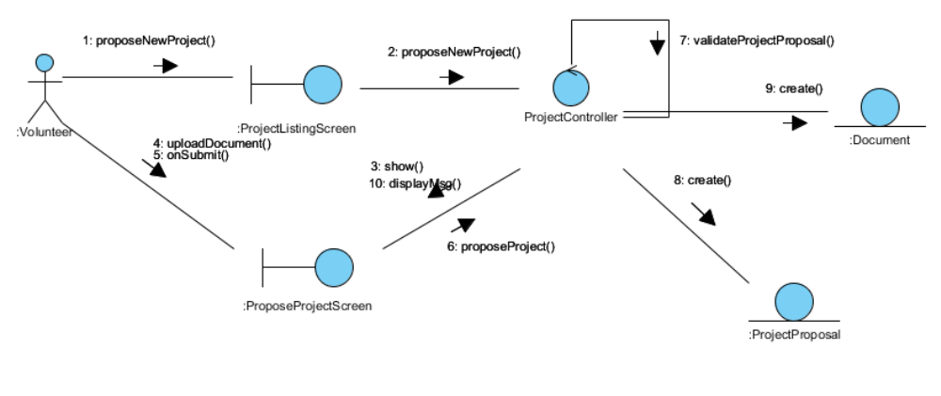
Figure 1 – Collaboration Diagram for Propose Project

Participating Objects

Volunteer
This actor represents a person a volunteer who wishes to participate in doing volunteer work at project sites. He can be a project member or project leader for a project site. A volunteer can register himself as a volunteer in order to participate in the project site.

ProjectProposal
This entity object stores the details concerning a project proposal that volunteer created. The primary attribute that it holds is the proposalID.

Document
This entity object stores the details concerning a document that volunteer uploaded. The primary attribute that it holds is the docID.

ProjectListingScreen
This boundary object is used for collection of project listing details. User actor uses this object.

ProjectProposalScreen
This boundary object is used for collection of project proposal. The Volunteer actor uses this object.

ProjectController
This control object co-ordinates the creation, update, viewing and searching project record in the volunteer management system. It receives requests from the boundary objects allocated for the specific purposes, along with all the necessary details required for the execution of these requests.

Class Diagram
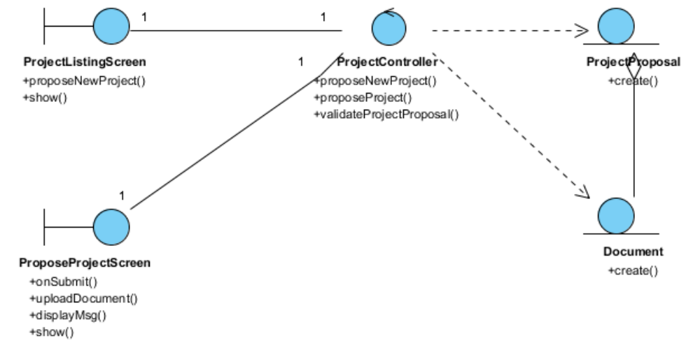
Figure 2 – Class Diagram

Derived Requirements
The User office PC (client system), keyboard and mouse will be used to process the project details and view all the system responses.

ANNEX D Amendment History

This is a record of all amendments made to the Document.
Version | Chapter / Section | Page No | Notes of Amendments or Changes

